Zid’Avwa Al Bari’i

244107020083 / TI – 2I / 26

# Jobsheet 6

## Perrcobaan 1

### Code

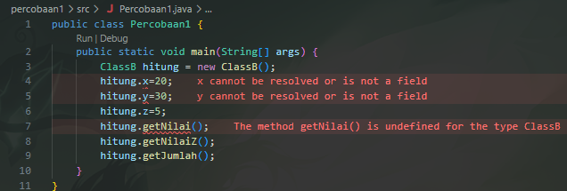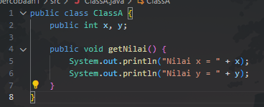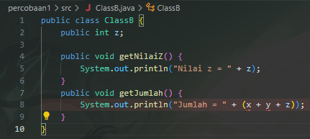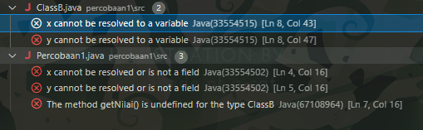

### Question

1. Fixing the program so it runs without error:

The error happens because ClassB tries to use x and y, but they are only defined in ClassA. To fix this, make ClassB extend ClassA so it inherits x, y, and getNilai().

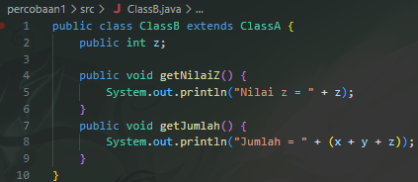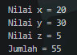

1. Explanation of the error cause:

The error happened because ClassB tried to access variables x and y that do not exist in its own class. They are declared in ClassA, but since ClassB was not connected to ClassA, the compiler could not find them.

## Percobaan 2

### Code

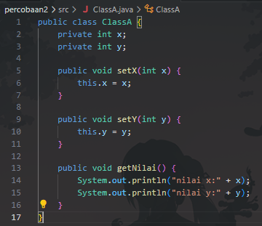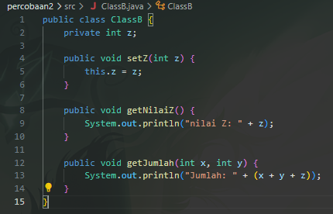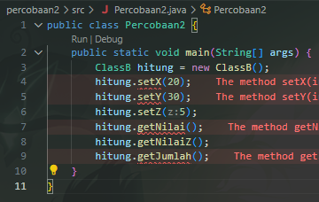

### Question

1. Fix the program in Experiment 2

The error happens because in Percobaan2, you call methods setX(), setY(), and getNilai() from ClassA, but you only created an object of ClassB, which does not inherit from ClassA.

Solution: Make ClassB extend ClassA. Then it will inherit x, y, setX(), setY(), and getNilai().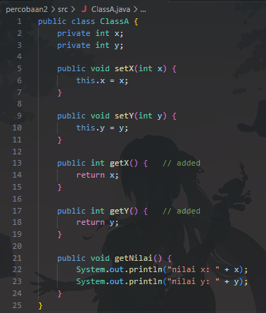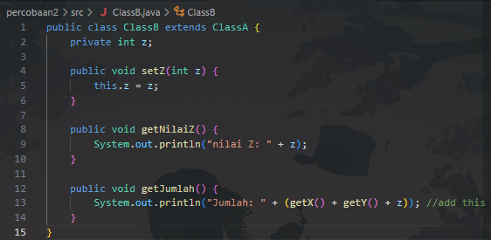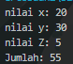

1. The error in experiment 2 happened because ClassB was created without extending ClassA. As a result, the object of ClassB could not use the methods setX(), setY(), and getNilai() that were defined in ClassA. That is why the compiler gave an error.

## Percobaan 3

### Code

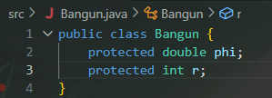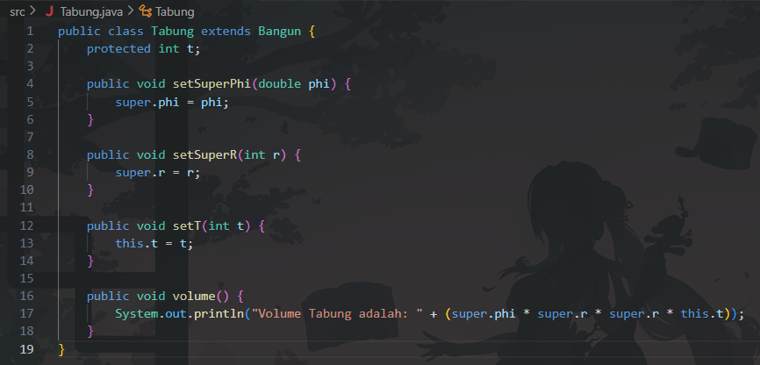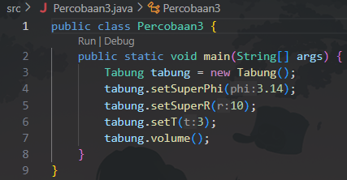

### Question

1. The keyword super is used to access attributes or methods from the parent class (Bangun).

In this program:

* super.phi = phi; = assigns a value to phi from the parent class.
* super.r = r; = assigns a value to r from the parent class.

1. super refers to attributes inherited from the parent class (Bangun). Example: super.phi and super.r.

this refers to attributes that belong to the current class (Tabung). Example: this.t.

So in the volume() method, super.phi * super.r * super.r * this.t multiplies the parent’s values (phi, r) with the child’s value (t).

1. The Tabung class can access phi and r because it inherits them from the parent class Bangun using extends.

Since phi and r are declared as protected in Bangun, they are directly accessible in the child class (Tabung).